TASK1:

1.Created a Jenkins job named nginx  
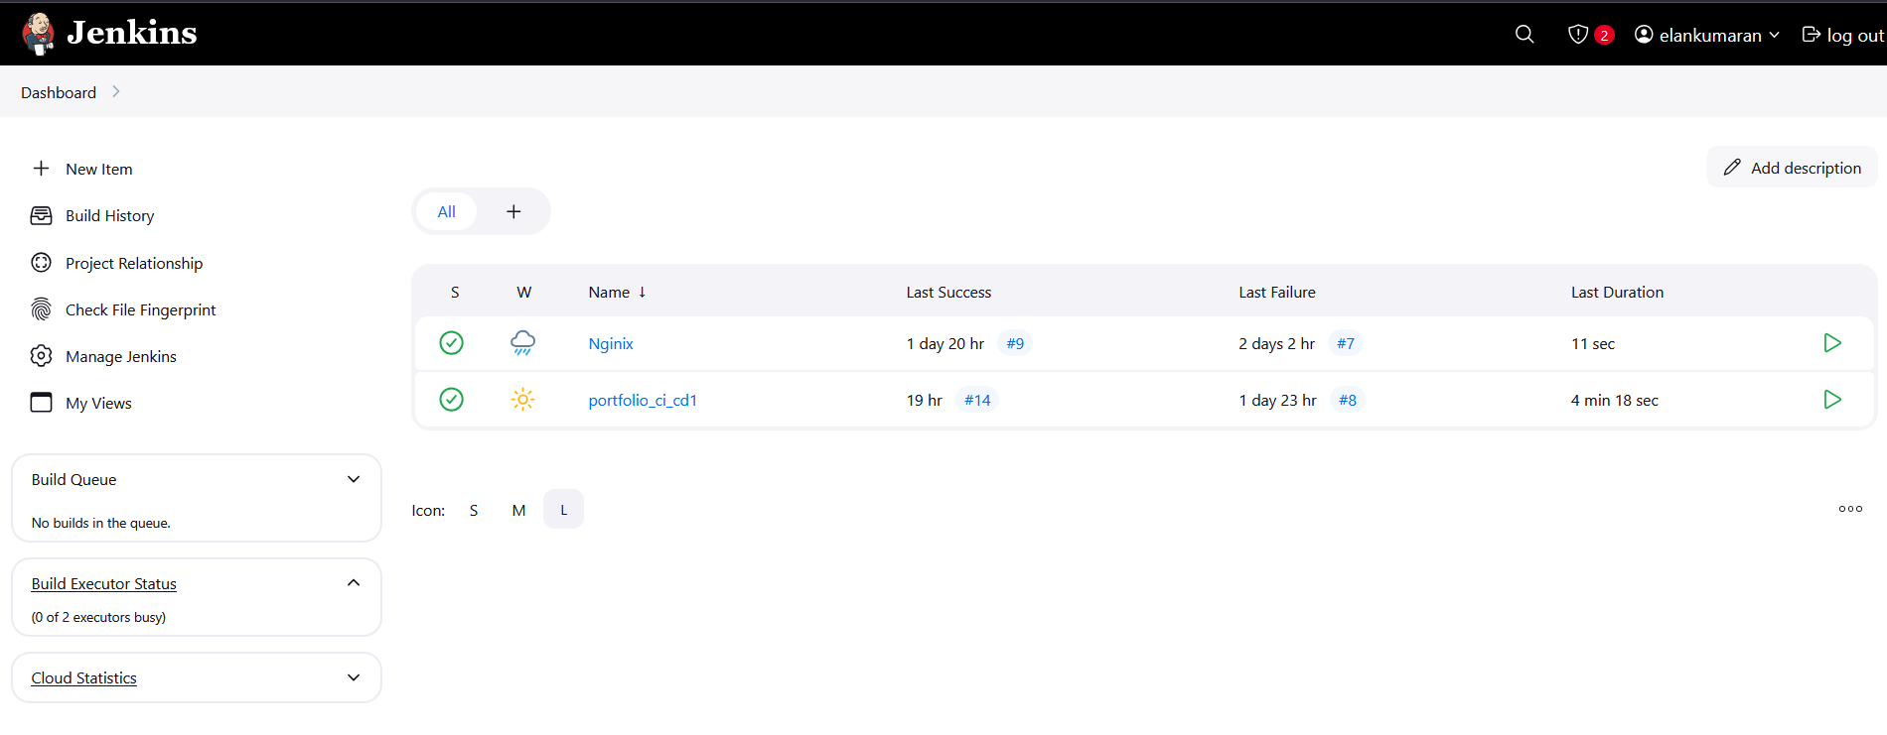

2. write the shell command to execute when the job build

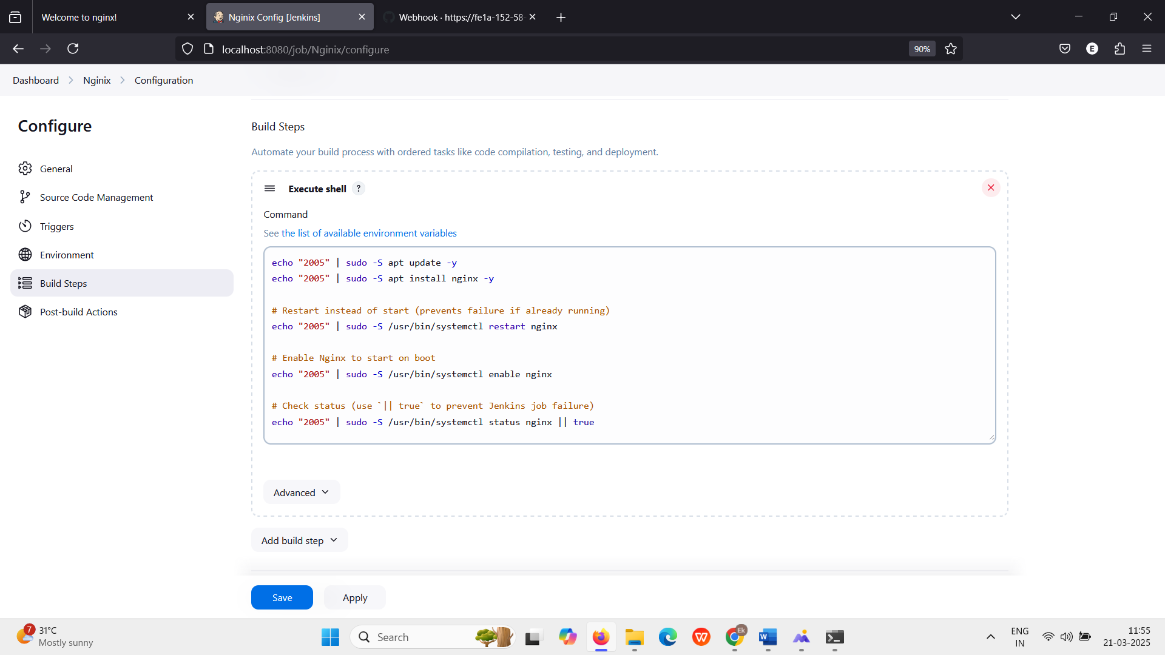

3. Output will be run in port 80

